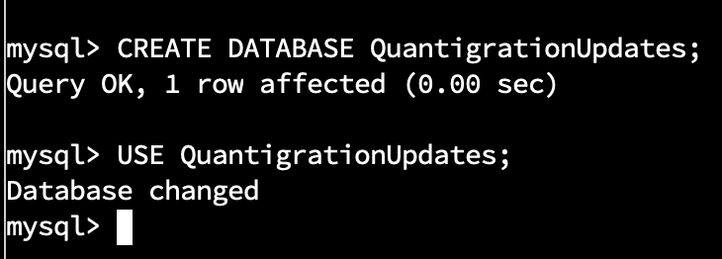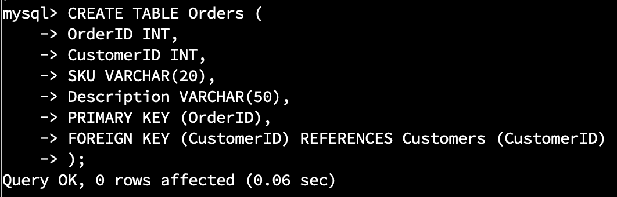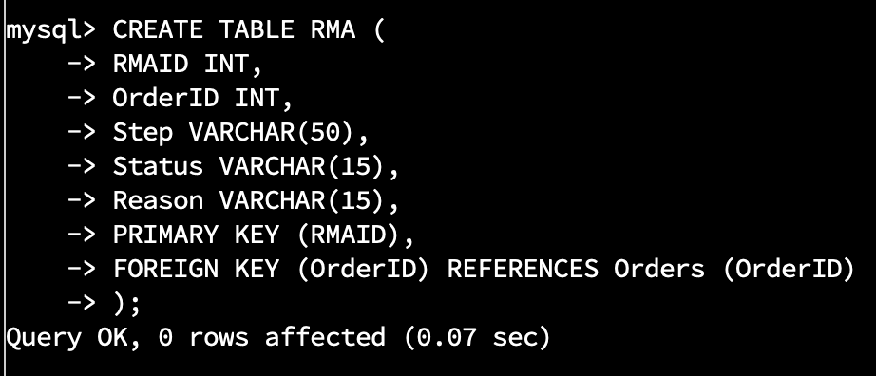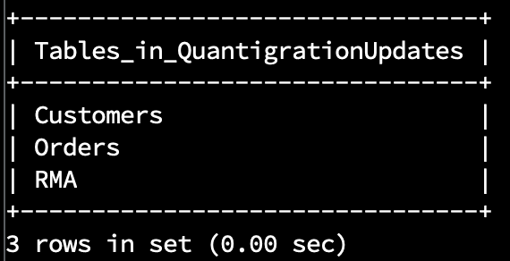

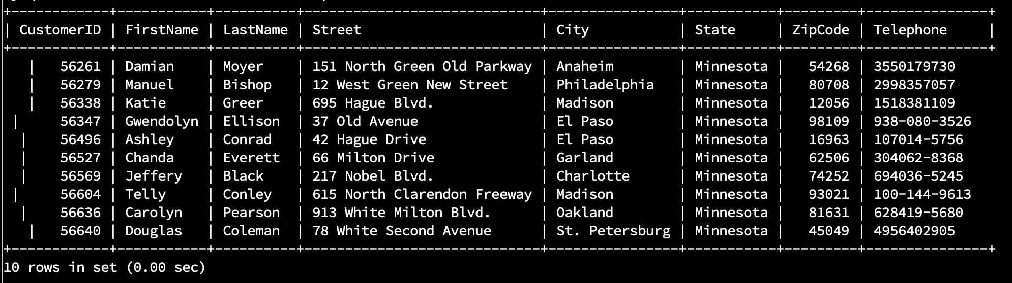

Basic query of all columns from the Customers table. This table contains customer’s personal data as well as a unique customer ID.

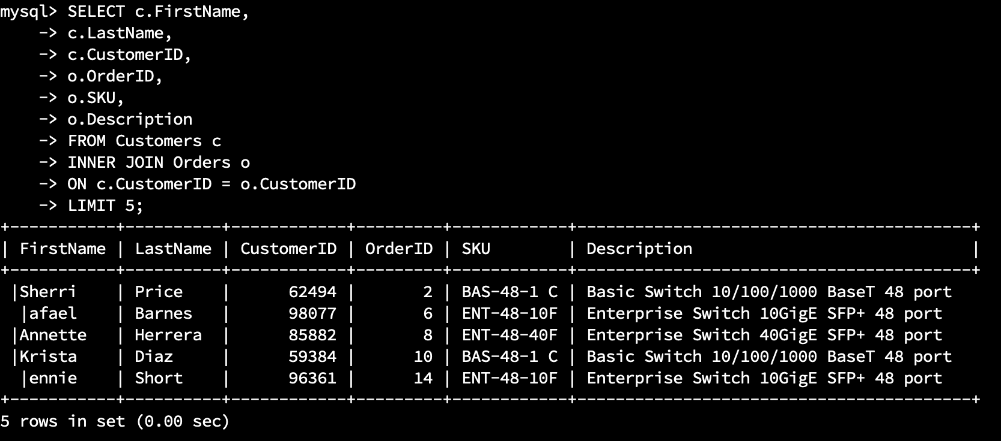

Here we did an “INNER JOIN” with the Customers and Orders table. The Orders table is a “child” of the Customers table and shares a one-to-many relationship as one customer can have many orders. Both tables have a CustomerID column that connects customers to their orders. This is a very powerful tool, as we can use the WHERE clause to find distinct data, like seeing how well a product is selling (shown below).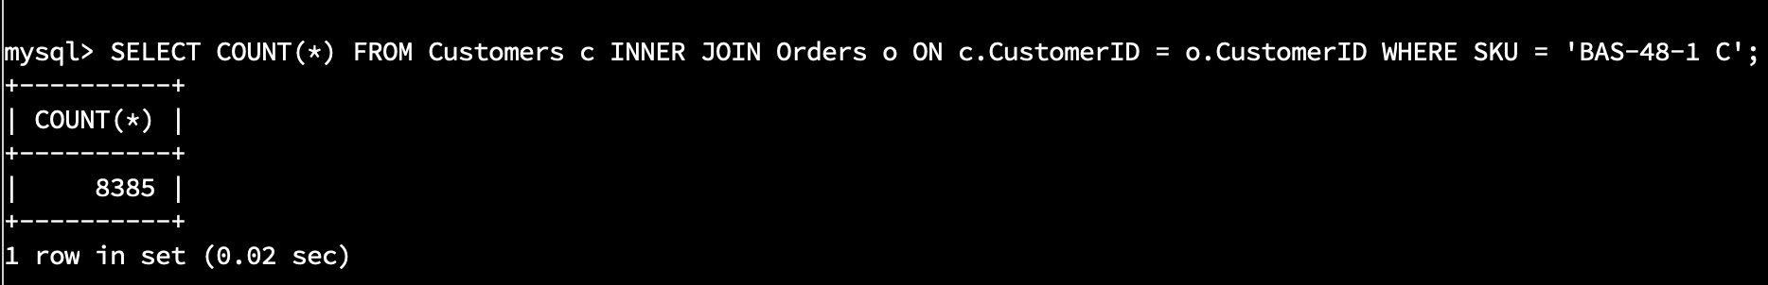

Below is the RMA table which records returned products. This table is a child of the Orders table and is connected to the Orders table via the OrderID column that both tables share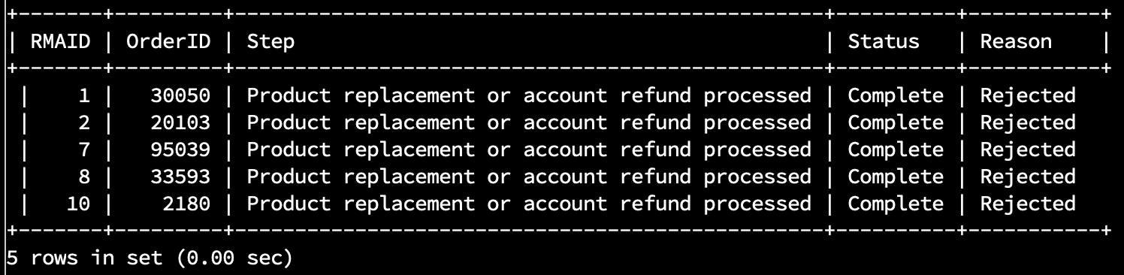

We can query all 3 tables for customer data, what they have ordered and what they have returned (below).

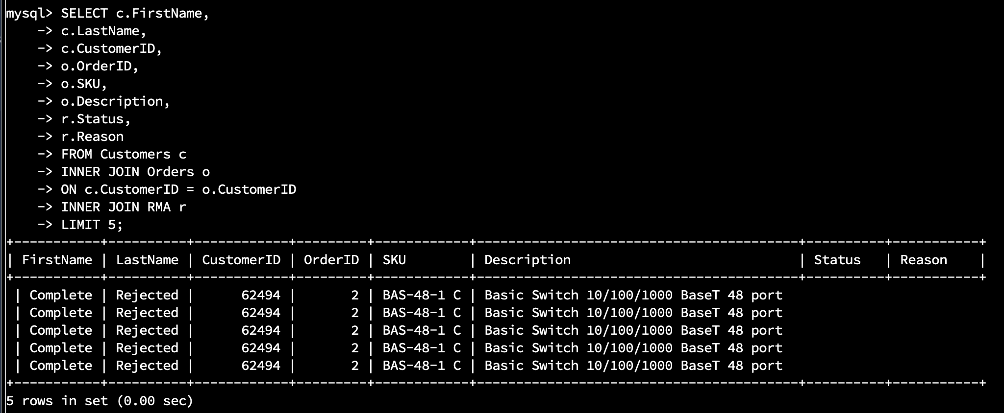

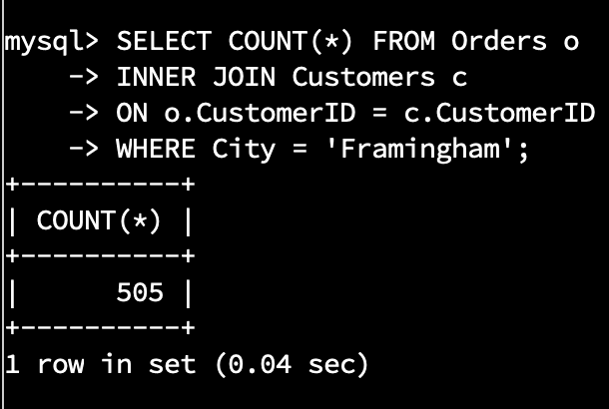

505 records returned

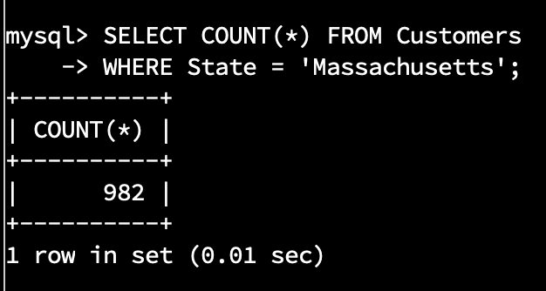

982 records returned

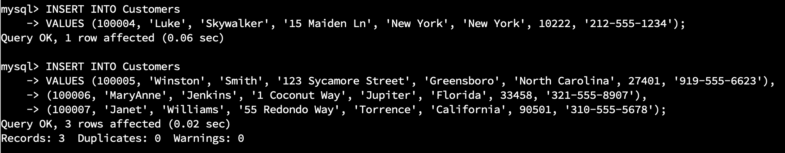

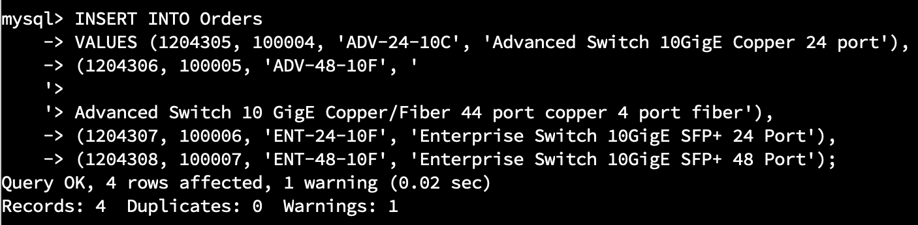

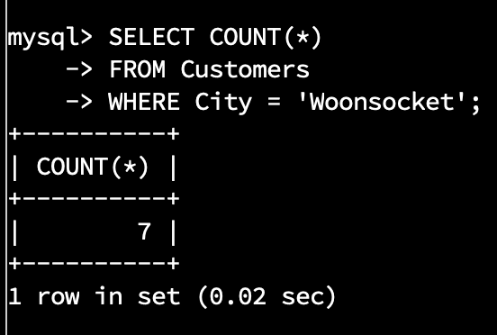

7 records returned

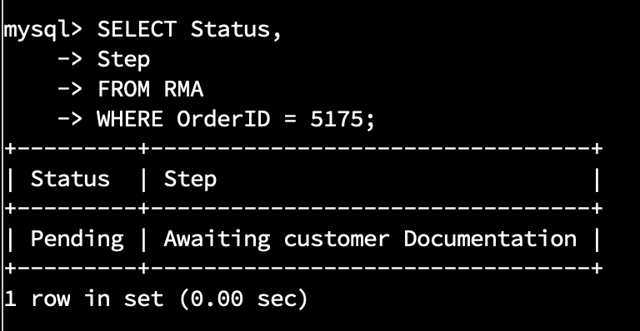

Status = ‘Pending’

Step = ‘Awaiting customer Documentation’

